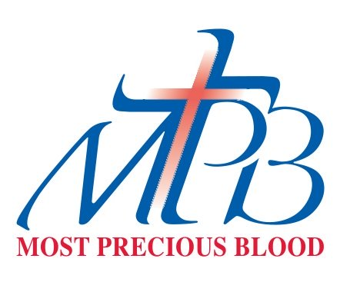**MOST PRECIOUS BLOOD CATHOLIC COMMUNITY**

**SOCIAL OUTREACH COMMITTEE**

**APPLICATION for ASSISTANCE 2020-2021**

The Social Outreach Committee of Most Precious Blood Catholic Community offers assistance to organizations that serve people in need.

When an organization applies for this yearly assistance, the request will be evaluated on the basis of the criteria listed below*.* Requests may be made for volunteers, material goods and/or financial assistance. Requests are considered quarterly and applicants will be notified of the status of their application upon receipt of the application.

Please answer the following questions:

1. How does your agency assist people in need?

1. How does your agency support clients to sustain a better quality of life? In what ways does your agency support clients beyond their immediate needs, i.e. training, counseling, education…
2. How do you know if you are successful in your mission? What are positive outcomes that you’ve observed in your clientele as a result of your support?
3. How will the requested funds specifically be used?
4. How does your agency serve a racially diverse population?

The Social Outreach Committee asks that the agency making a request for 2019-2020 submit this form to Most Precious Blood Parish attn.: Ann Zimmer. Requests are reviewed quarterly. Requests for 2020-21 must be made before May 1, 2021.

**Ann Zimmer Social Outreach Coordinator**

[**azimmer@mpbdenver.org**](mailto:azimmer@mpbdenver.org)

**303.756.3083 phone 303.756.5628 fax**

**Contact Ann with any questions.**



**MOST PRECIOUS BLOOD COMMUNITY**

**SOCIAL OUTREACH COMMITTEE**

**APPLICATION for ASSISTANCE 2020-2021**

Agency__ ________________________

Date of Application_________________

Project Title or Focus of Funding ________________________________

________________________________

Address ________________________

________________________________

Phone___________________________

Email___________________________

Contact Person

________________________________

Year of Incorporation

____________________

Agency’s Fiscal Year

_________________

**Human Resources:**

Number of Staff ___________

Number of Volunteers________

Number of Clients Served __________

**Total Assistance Requested:**

Financial request $ ________________

Other assistance requested

________________________________

Would you be willing to present to the committee / parish your project or work?_________

How did you learn of this MPB resource?

________________________________

Previously funded by MPB?

Yes_______ No________

If yes:

Date(s)____________________

Amount(s)________________________

**********************************************

**Please enclose the following documents with this request:**

* Annual financial statement
* Names of other agencies or parishes that assist your organization.
* Your agency’s mission statement

Administrator Signature

Date: _______________________

6.30.20 Rev